Destination:

XIFAXAN Coverage

98% of commercially insured patients
have coverage for XIFAXAN.^{1*†}
100% of Medicare Part D patients have coverage for XIFAXAN.^{1*†} Dual-eligible patients may pay
as little as $12.15.²

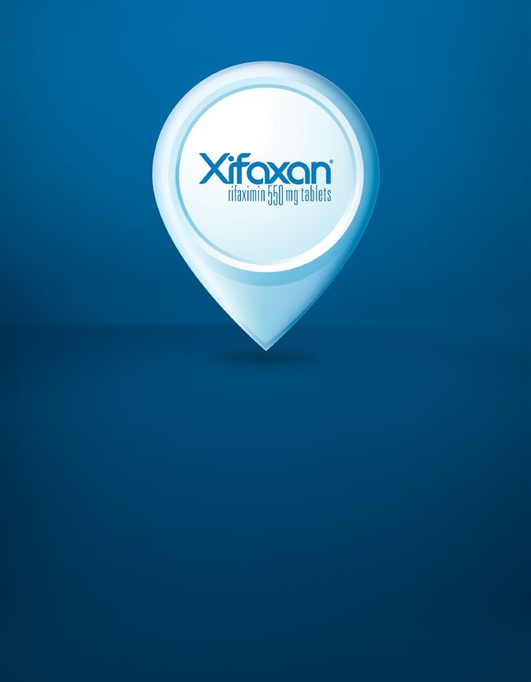
94% of eligible, commercially insured patients
who had coverage for XIFAXAN paid $10 or less for their prescription when a copay card or eVoucher was applied in the last year (October 2023 to October 2024).³

Branded Prior Authorizations (PAs) are common. Initiate a Pull Through protocol to proactively submit PAs to ensure timely and efficient outcomes.

*Salix Pharmaceuticals does not guarantee coverage or reimbursement for the product.
†Formulary status subject to change.




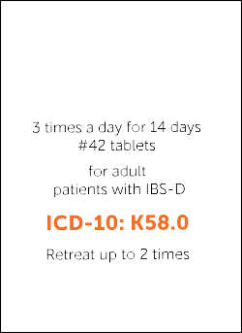

Steps to Complete a PA for Patients with IBS-D
Double-check Top Reasons for PA Denials Before Submitting
‡The ICD-10 codes and all other patient access-related information are provided for informational purposes only. It is the treating physician’s responsibility to determine the proper diagnosis, treatment, and applicable ICD-10 code.
§Submission is not a guarantee of coverage or payment. Payer coverage is subject to change without notice.
INDICATIONS
XIFAXAN® (rifaximin) 550 mg tablets are indicated for the treatment of irritable bowel syndrome with diarrhea (IBS-D) in adults and for the reduction in risk of overt hepatic encephalopathy (HE) recurrence in adults.
IMPORTANT SAFETY INFORMATION
- XIFAXAN is contraindicated in patients with a hypersensitivity to rifaximin, rifamycin antimicrobial agents, or any of the components in XIFAXAN. Hypersensitivity reactions have included exfoliative dermatitis, angioneurotic edema, and anaphylaxis.
Please see additional Important Safety Information throughout and click here for full Prescribing Information.
XIFAXAN® (rifaximin) 550 mg tablets are indicated for the treatment of irritable bowel syndrome with diarrhea
(IBS-D) in adults⁵. When a PA is required for XIFAXAN, be sure that all information is included and accurate.

Step 1 Provide patient and insurance information
Step 2 Include prescriber information
(eg, practice name, your name, NPI #, DEA/License #)

Step 3 Provide accurate information, including:
- Age, diagnosis, dosing
Age of patient, IBS-D, XIFAXAN 550 mg, three times a day/14 days, 42 tablets⁴
- ICD-10 code for IBS-D⁵‡
‡ K58.0 Irritable bowel syndrome with diarrhea
- Previous therapies tried and failed⁶
(eg, antidiarrheals, antispasmodics, loperamide, SSRIs, TCAs)
- Rationale for prescribing XIFAXAN
Step 4 Remember your signature and the date

PA support is available when XIFAXAN is prescribed through CoverMyMeds

REASON FOR DENIAL | CONSIDERATIONS FOR AVOIDING DENIAL
Prior authorization not completed | Confirm PA, fill in missing information, and resubmit
Dosing does not match Indication | Confirm dosing  - For IBS-D: XIFAXAN 550 mg, three times a day/14 days, 42 tablets⁴  - For OHE: XIFAXAN 550 mg, twice daily, 60 tablets⁴
Invalid diagnosis code | Confirm ICD-10 code and resubmit‡§  - IBS-D: K58.0 Irritable bowel syndrome with diarrhea⁵  - Overt HE: K76.82 Hepatic Encephalopathy.⁵
Did not try & fail formulary alternative | Include information on why XIFAXAN is necessary and how you expect it to help the patient
Product is a plan exclusion | Confirm coverage; Medicare excludes certain kinds of drugs, but XIFAXAN is not in those categories
Medication not covered | You can ask insurance plan to reevaluate; XIFAXAN is covered for 98% of commercially insured patients and 99.7% of Medicare patients¹*

Steps to Complete a PA for Patients with Overt HE
XIFAXAN® (rifaximin) 550 mg tablets are indicated for the reduction in risk of overt hepatic encephalopathy
(OHE) recurrence in adults⁵. When a PA is required for XIFAXAN, be sure that all information is included and accurate.

Step 1 Provide patient and insurance information
Step 2 Include prescriber information
(eg, practice name, your name, NPI #, DEA/License #)

Step 3 Provide accurate information, including:
- Age, diagnosis, dosing
Age of patient, twice daily, 60 tablets with refills^{4||}
- ICD-10 code for OHE^{5‡}
K76.82 Hepatic encephalopathy (indicate lactulose history if applicable)
- Previous therapies tried and failed⁴
(eg, lactulose)
‡
- Rationale for prescribing XIFAXAN
(eg, breakthrough OHE episode while on lactulose)

Step 4 Remember your signature and the date

PA support is available when XIFAXAN is prescribed through CoverMyMeds

A Letter of Medical Necessity may be needed. If so, it is important to:

- Keep it concise
- Submit on practice letterhead
- Include patient name
- Include name of medication
(eg, XIFAXAN 550 mg)
- Specify diagnosis (eg, IBS-D or OHE)
- State your treatment rationale
- Specify duration of treatment (eg, 14 days for IBS-D; as long as recommended for OHE)⁴
- Include your name, signature, and date
Please visit https://www.xifaxan.com/siteassets/ hehcp/pdf/xifaxan-medical-necessity-form.pdf for a sample Letter of Medical Necessity



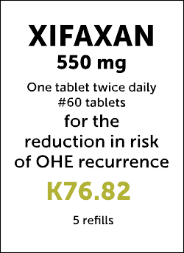
DEA, Drug Enforcement Agency; NPI, National Provider Identifier; SSRI, selective serotonin reuptake inhibitor; TCA, tricyclic antidepressant.
||If coverage allows refills, write for 180 tablets.

IMPORTANT SAFETY INFORMATION (continued)
- Clostridium difficile-associated diarrhea (CDAD) has been reported with use of nearly all antibacterial agents, including XIFAXAN, and may range in severity from mild diarrhea to fatal colitis. If CDAD is suspected or confirmed, ongoing antibiotic use not directed against C. difficile may need to be discontinued.
- There is an increased systemic exposure in patients with severe (Child-Pugh Class C) hepatic impairment. Caution should be exercised when administering XIFAXAN to these patients.
- Caution should be exercised when concomitant use of XIFAXAN and P-glycoprotein (P-gp) and/or OATPs inhibitors is needed. Concomitant administration of cyclosporine, an inhibitor of P-gp and OATPs, significantly increased the systemic exposure of rifaximin. In patients with hepatic impairment, a potential additive effect of reduced metabolism and concomitant P-gp inhibitors may further increase the systemic exposure to rifaximin.
Please see additional Important Safety Information throughout and click here for full Prescribing Information.

XIFAXAN has a straightforward prior authorization (PA) process

The XIFAXAN PA process is a simple way to help your adult patients diagnosed with IBS-D or OHE access the treatment you prescribe
When a PA is required, be sure the following information is included and accurate:

Indication:

IBS-D: K58.0, the
ICD-10 code for IBS-D⁵
OHE: K76.82, the
ICD-10 code for OHE⁵
(indicate lactulose history if applicable)

Dosing:
IBS-D: #42 XIFAXAN 550-mg tablets, 3 times a day by mouth for 2 weeks⁴
OHE: #60 XIFAXAN 550-mg tablets, twice daily with refills⁴
Age: 18 years or older⁴

Previous therapies tried and failed: IBS-D: eg, antidiarrheals, antispasmodics, loperamide, SSRIs, TCAs, and other
OTC medications
OHE: eg, lactulose






Help your patients start and stay on XIFAXAN as required
The most common reasons for treatment rejection are failure to initiate a PA, providing inaccurate information, and/or submitting incomplete forms. Watch out for these errors when filling out a PA:
- Missing signature
- Absent or invalid ICD-10 code
- Incorrect dosing for the indication
IMPORTANT SAFETY INFORMATION (continued)
- In clinical studies, the most common adverse reactions for XIFAXAN (alone or in combination with lactulose) were:
  - IBS-D (≥2%): Nausea (3%), ALT increased (2%)
  - HE (≥10%): Peripheral edema (17%), constipation (16%), nausea (15%), fatigue (14%), insomnia (14%), ascites (13%), dizziness (13%), urinary
tract infection (12%), anemia (10%), and pruritus (10%)
- INR changes have been reported in patients receiving rifaximin and warfarin concomitantly. Monitor INR and prothrombin time. Dose adjustment of warfarin may be required.
- XIFAXAN may cause fetal harm. Advise pregnant women of the potential risk to a fetus.
To report SUSPECTED ADVERSE REACTIONS, contact Salix Pharmaceuticals at 1-800-321-4576 or FDA at 1-800-FDA-1088 or www.fda.gov/medwatch.

Please see additional Important Safety Information throughout and click here for full Prescribing Information.

References: 1. Data on file. MMIT September 2023. Salix Pharmaceuticals, Bridgewater, NJ. 2. Help with drug costs. Medicare.gov: https://www.medicare.gov/basics/costs/help/drug-costs. Accessed: January 3, 2025. 3. Data on File. Patient Copay Sept/Oct 2023-Sept/Oct 2024. Salix Pharmaceuticals. Bridgewater, NJ. 4. XIFAXAN. Prescribing Information. Salix Pharmaceuticals; 2023. 5. ICD-10. Centers for Medicaid & Medicare Services: https://www.cms.gov/medicare/coding-billing/icd-10-codes. Accessed January 3, 2025. 6. Grundmann O, Yoon SL. Irritable bowel syndrome: epidemiology, diagnosis and treatment: an update for health-care practitioners. J Gastroenterol Hepatol. 2010;25(4):691-699.

Salix Pharmaceuticals: 400 Somerset Corporate Blvd., Bridgewater, NJ 08807 The XIFAXAN 550 mg product and the XIFAXAN trademark are licensed by Alfasigma S.p.A. to Salix Pharmaceuticals or its affiliates.
© 2025 Salix Pharmaceuticals or its affiliates. XIFI.0077.USA.22V3.0

